**Instructions for Lab 1**

**Part I**

Downloading MySQL Workbench

1. Navigate to <https://dev.mysql.com/downloads/workbench/>
2. Select your operating system (Mac/Windows) and click **Download**. Example below is for MacOS:

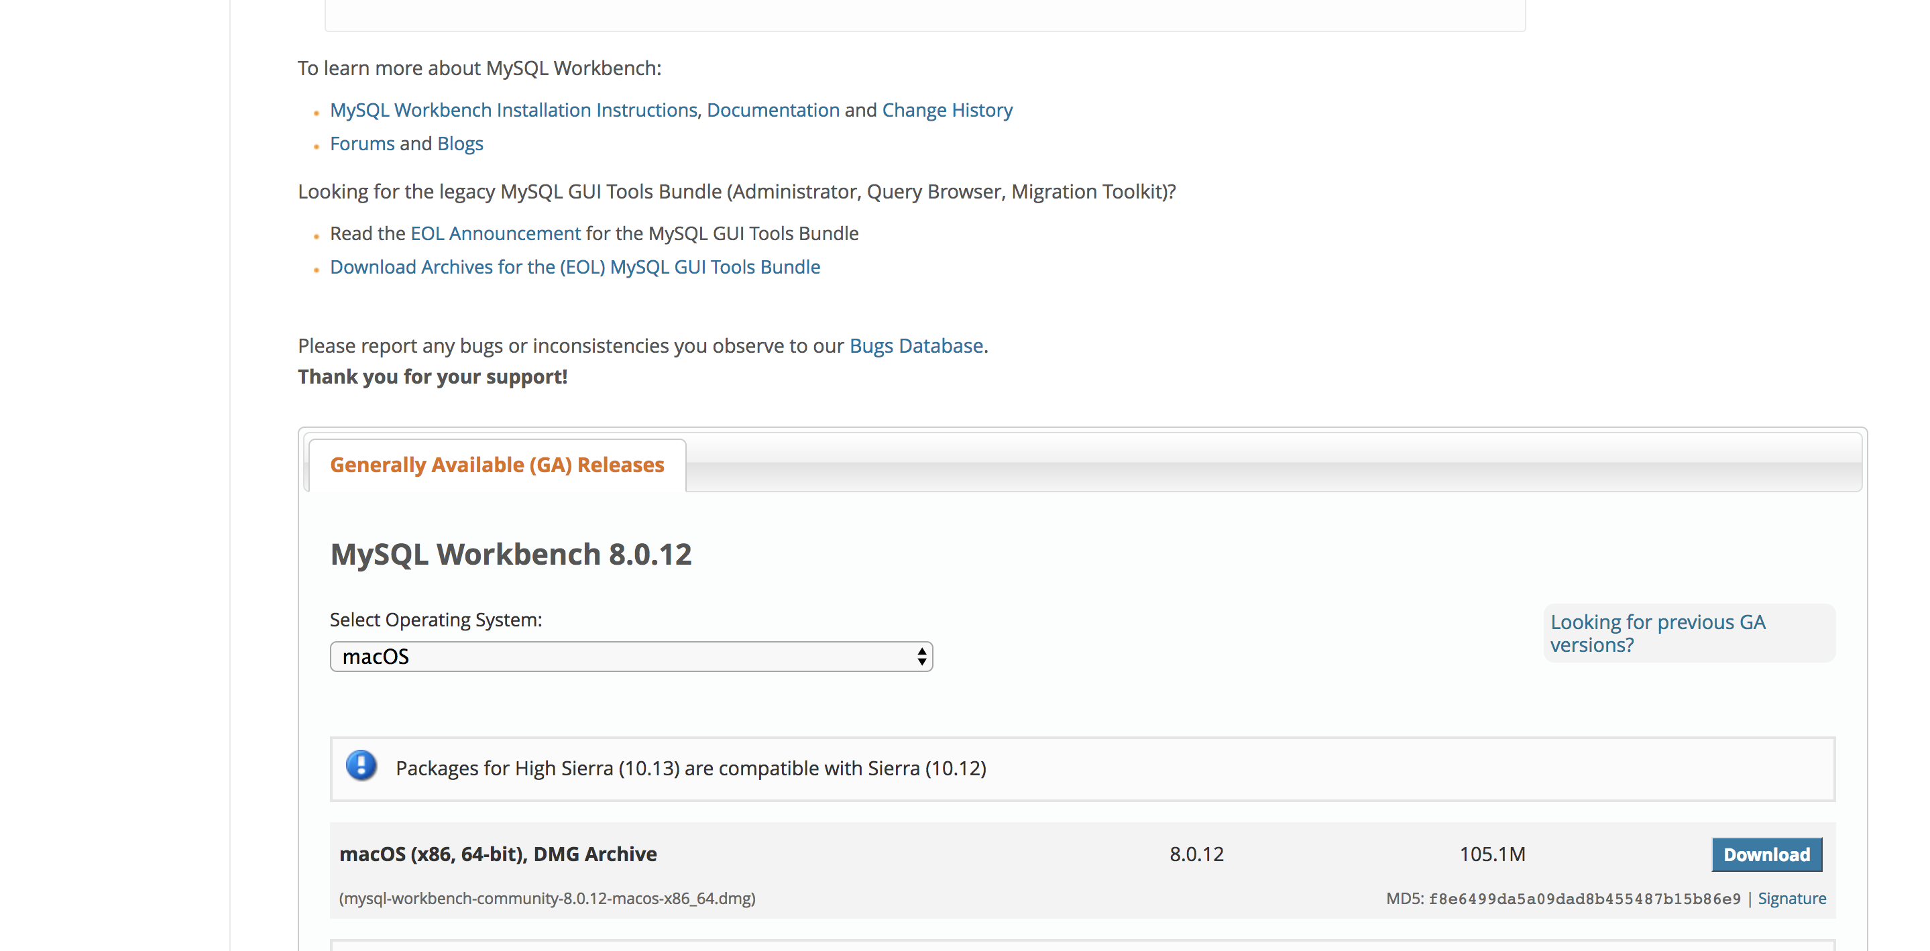

1. You will be prompted to either login to Oracle Web account or sign up for one, ignore both and click on the following the link below in blue **No thanks, just start my download:**

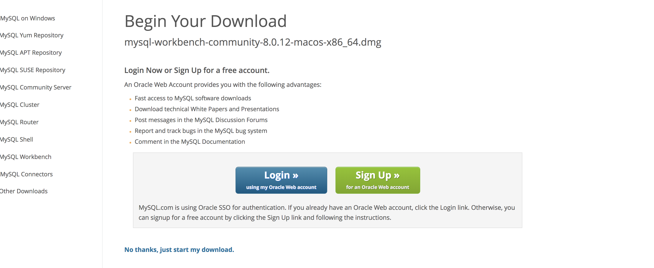

1. After the download completes, click on the dmg file as it will prompt the installer to start the download process:

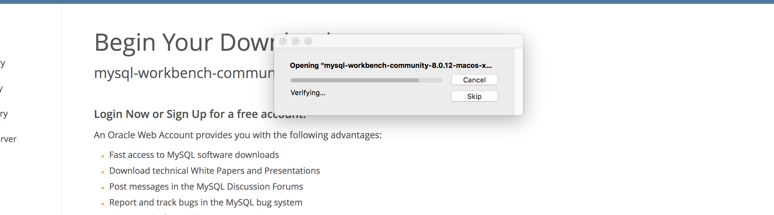

1. Move MySQL Workbench to your Applications folder:

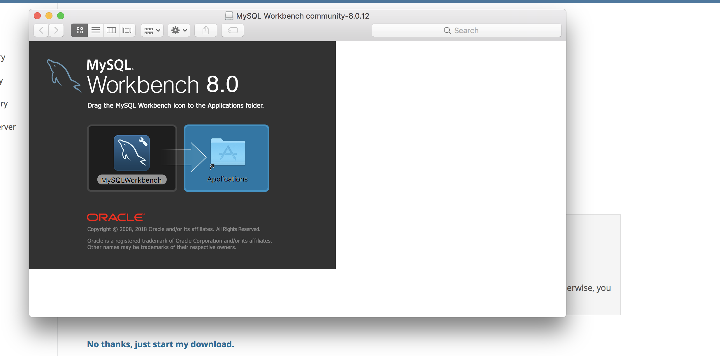

1. You will now see MySQLWorkbench in your applications folder:

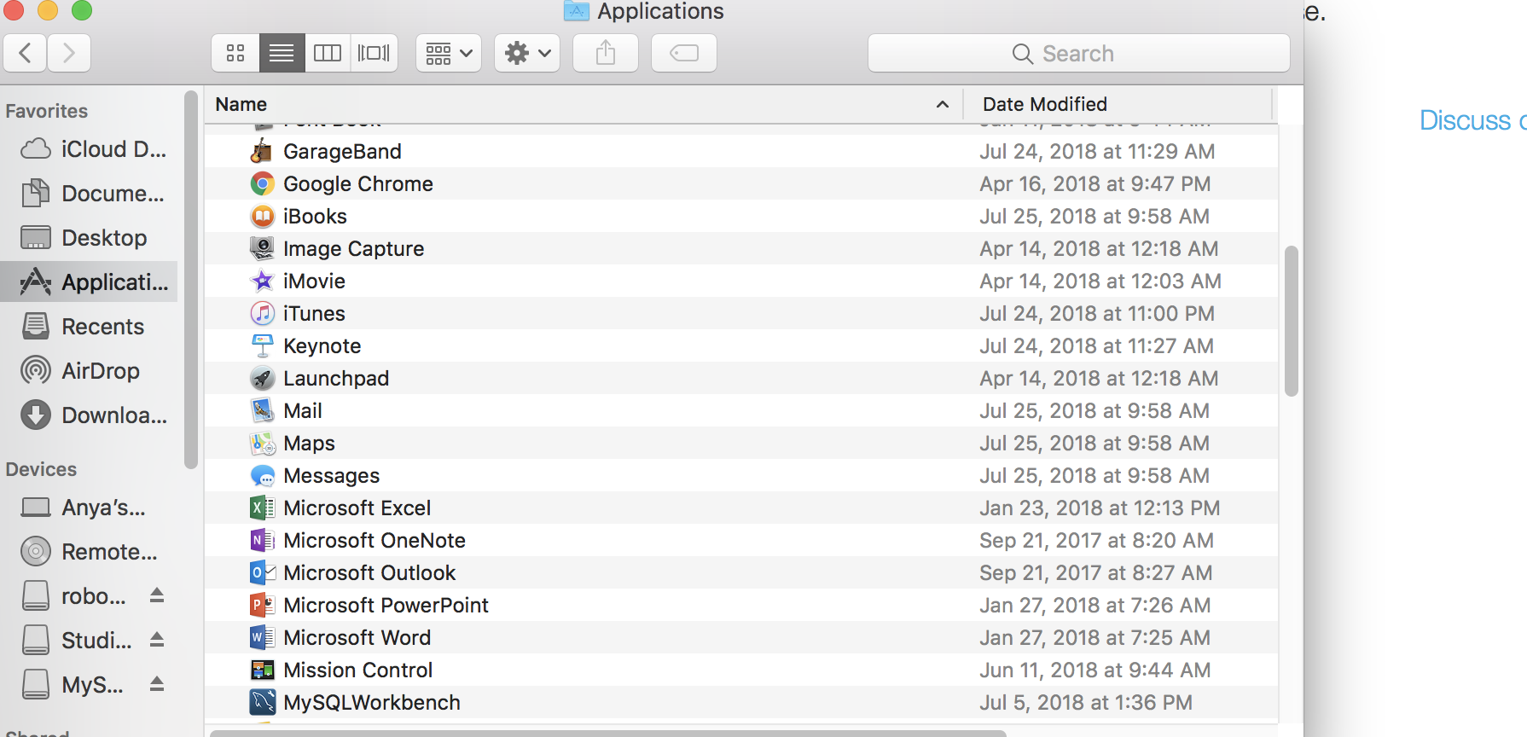

**Part II**

Download GWU VPN

Follow this link 🡪 <https://it.gwu.edu/vpn>

**Part III**

Create MySQL RDS Database Instance

1. Login to AWS per instructions provided previously: <http://go.gwu.edu/idpinit>

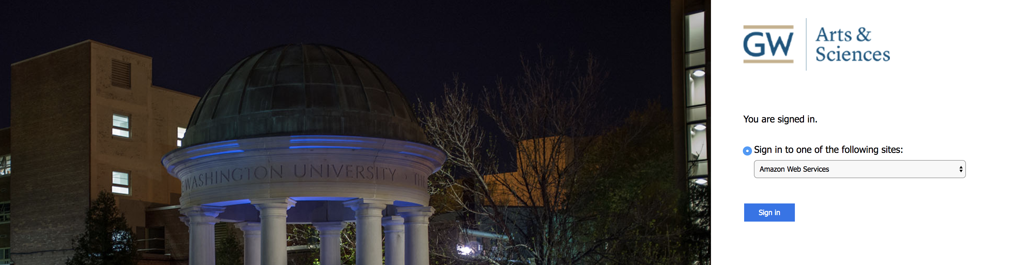

1. Navigate to Services 🡪 Database 🡪 RDS as follows:

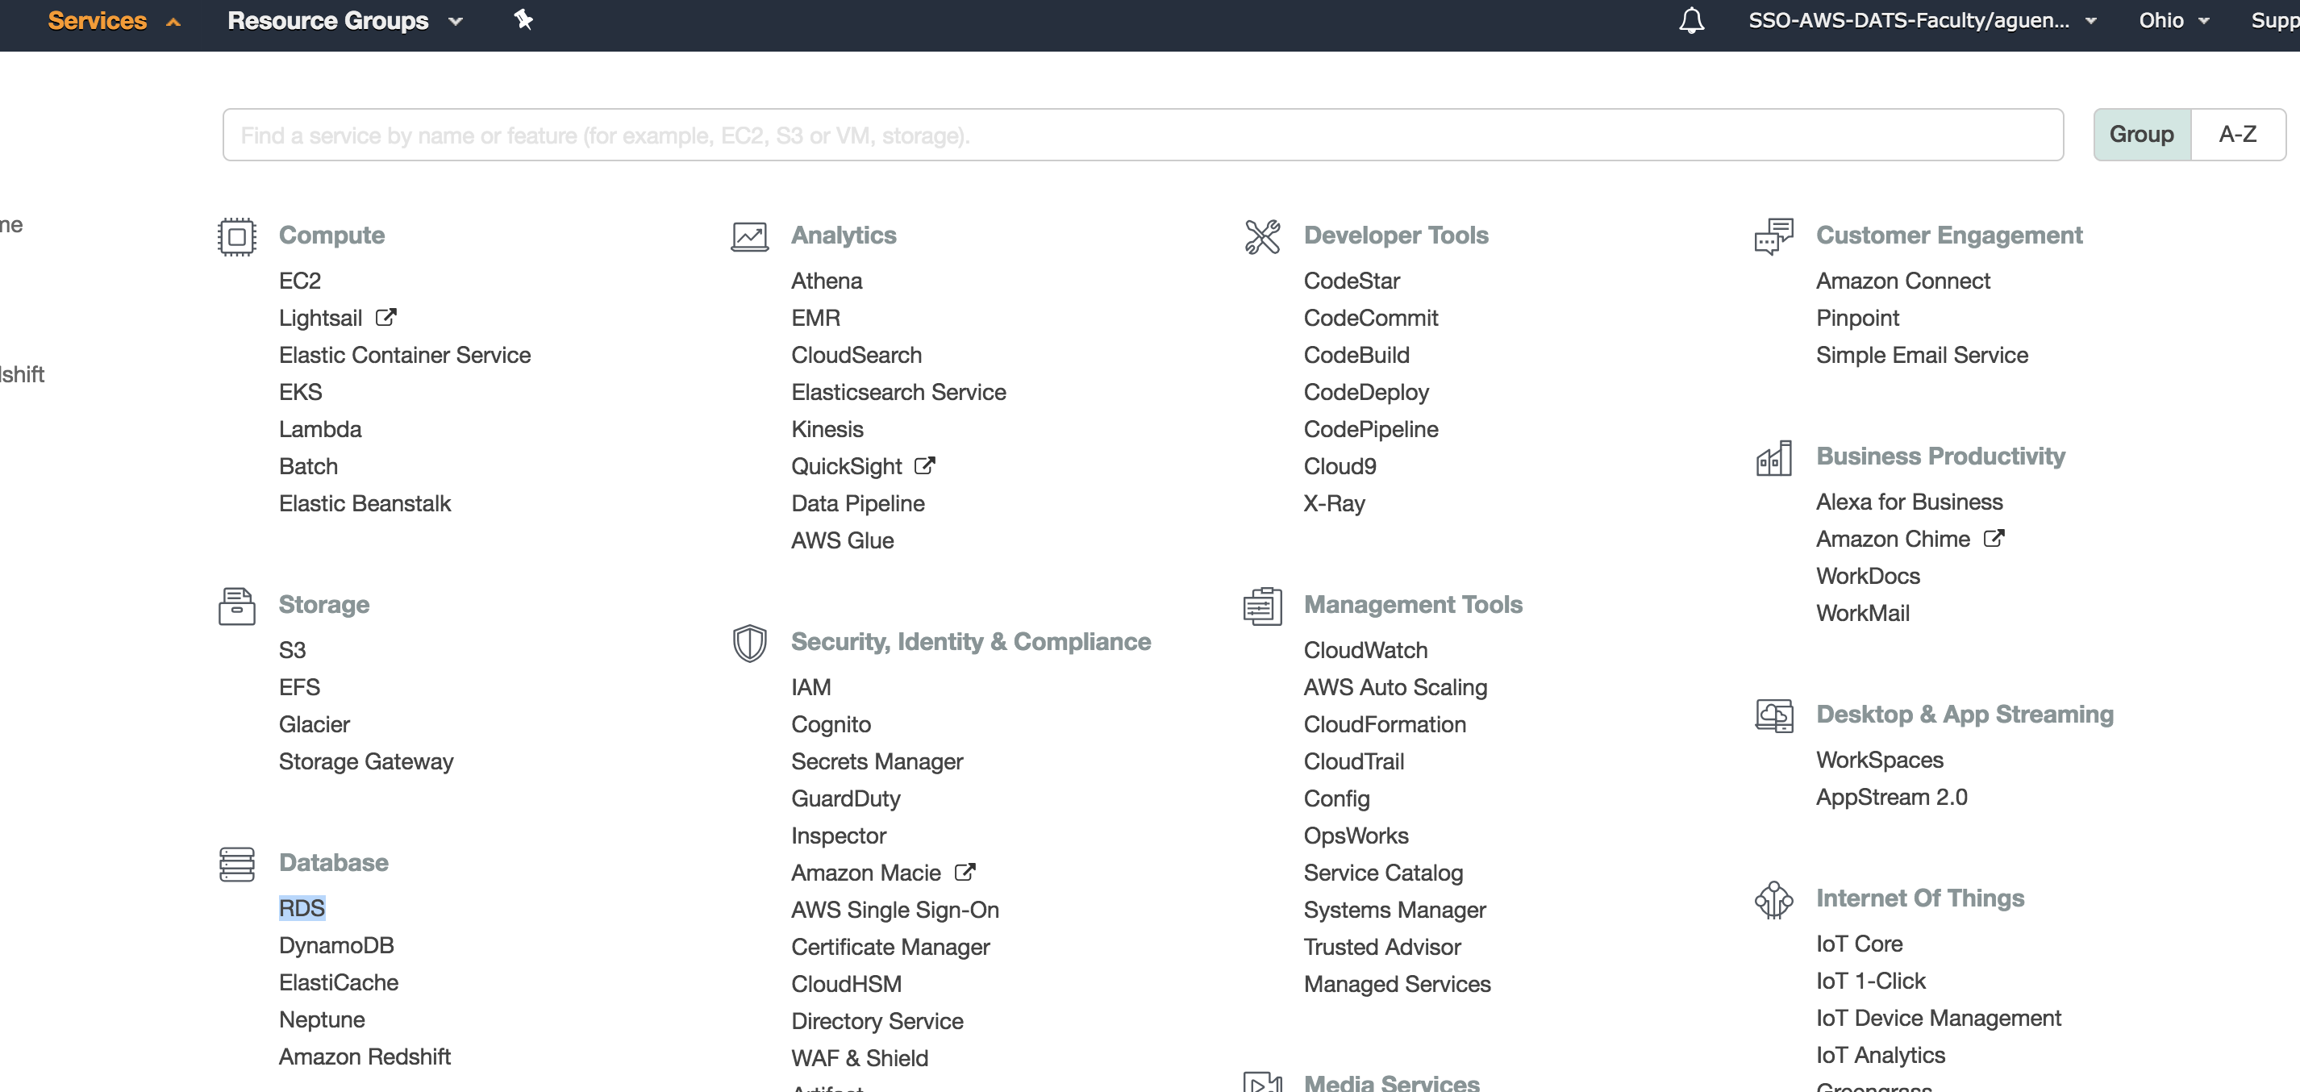

1. Choose:
   * MySQL
   * Standard Create
   * Free Tier

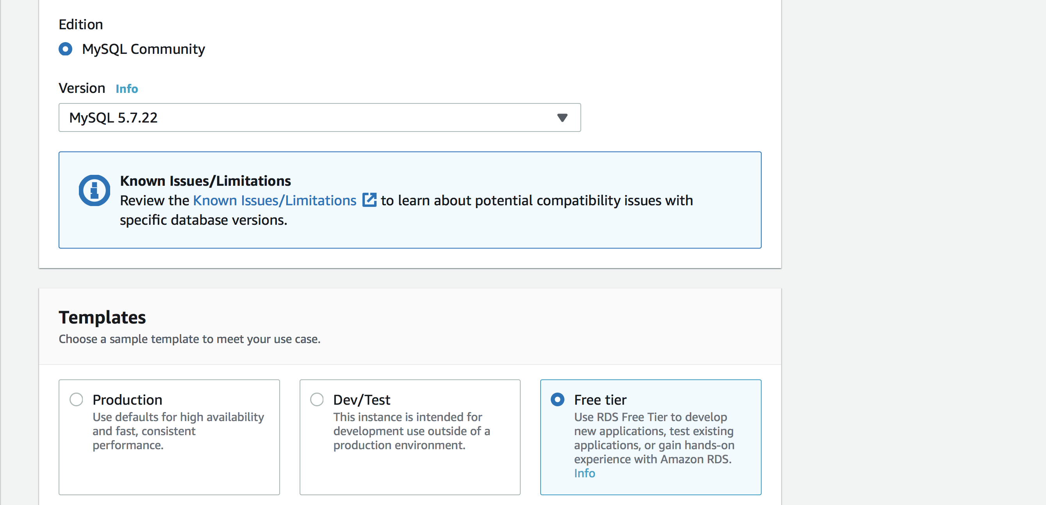

1. **Settings:**

* DB instance identifier – give your database a unique name (your NetID with the word DB appended). For example, I named mine **aguenissDB2**

1. **Credential Settings**

* Provide Master username (this is unique to your database so write down the username that you will remember
* Provide Master password (write down the password that you will remember), don’t autogenerate one

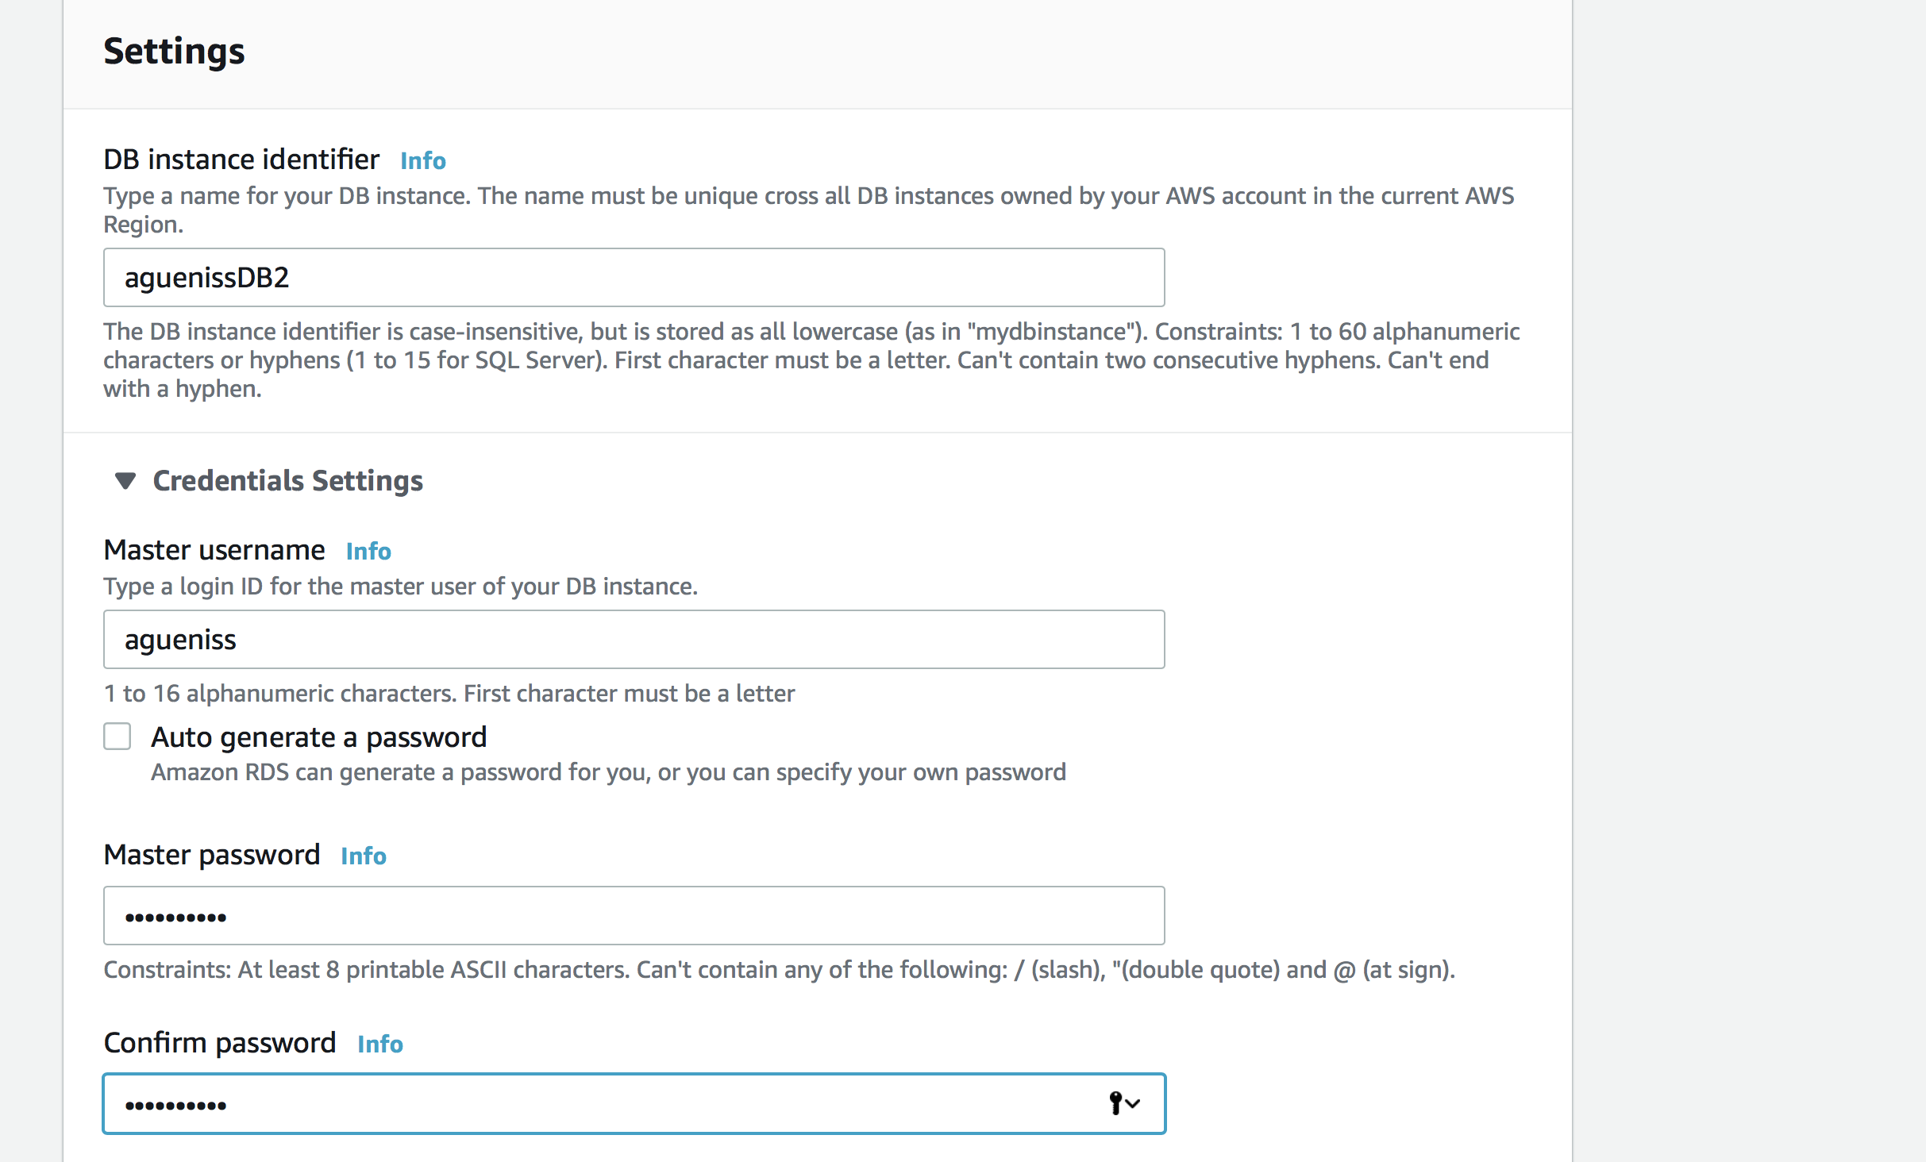

1. **Connectivity**

* Leave Default VPC

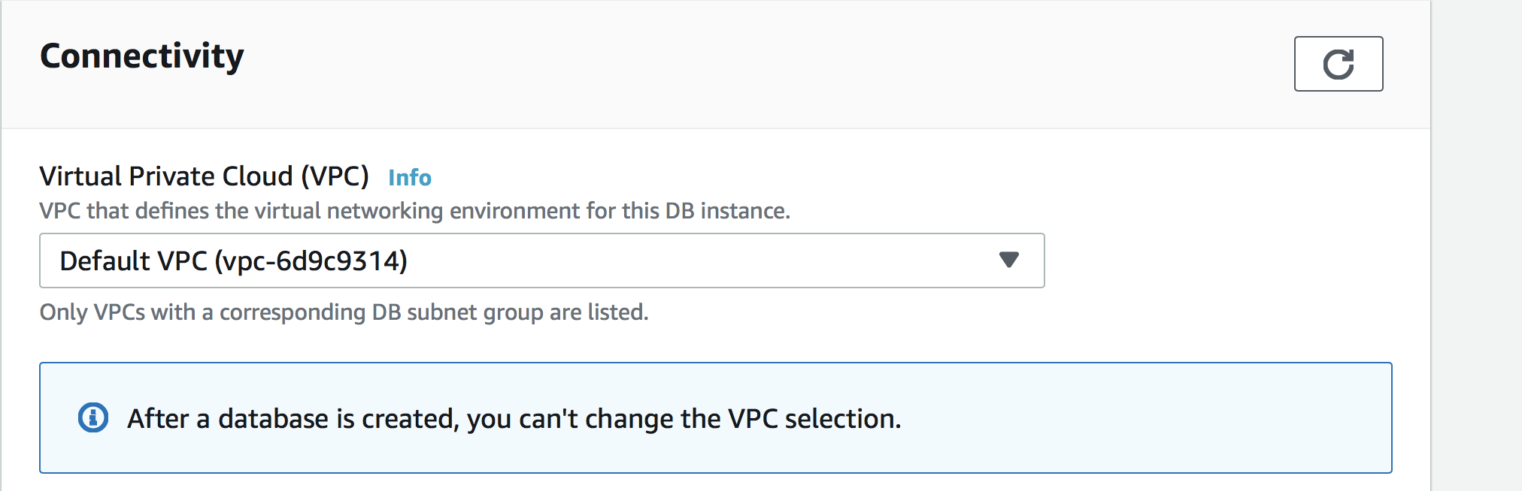

1. **Additional connectivity configuration**

* Publicly accessible – **Yes**
* **VPC security group – Choose existing – DataScience-DW-GWU-All**

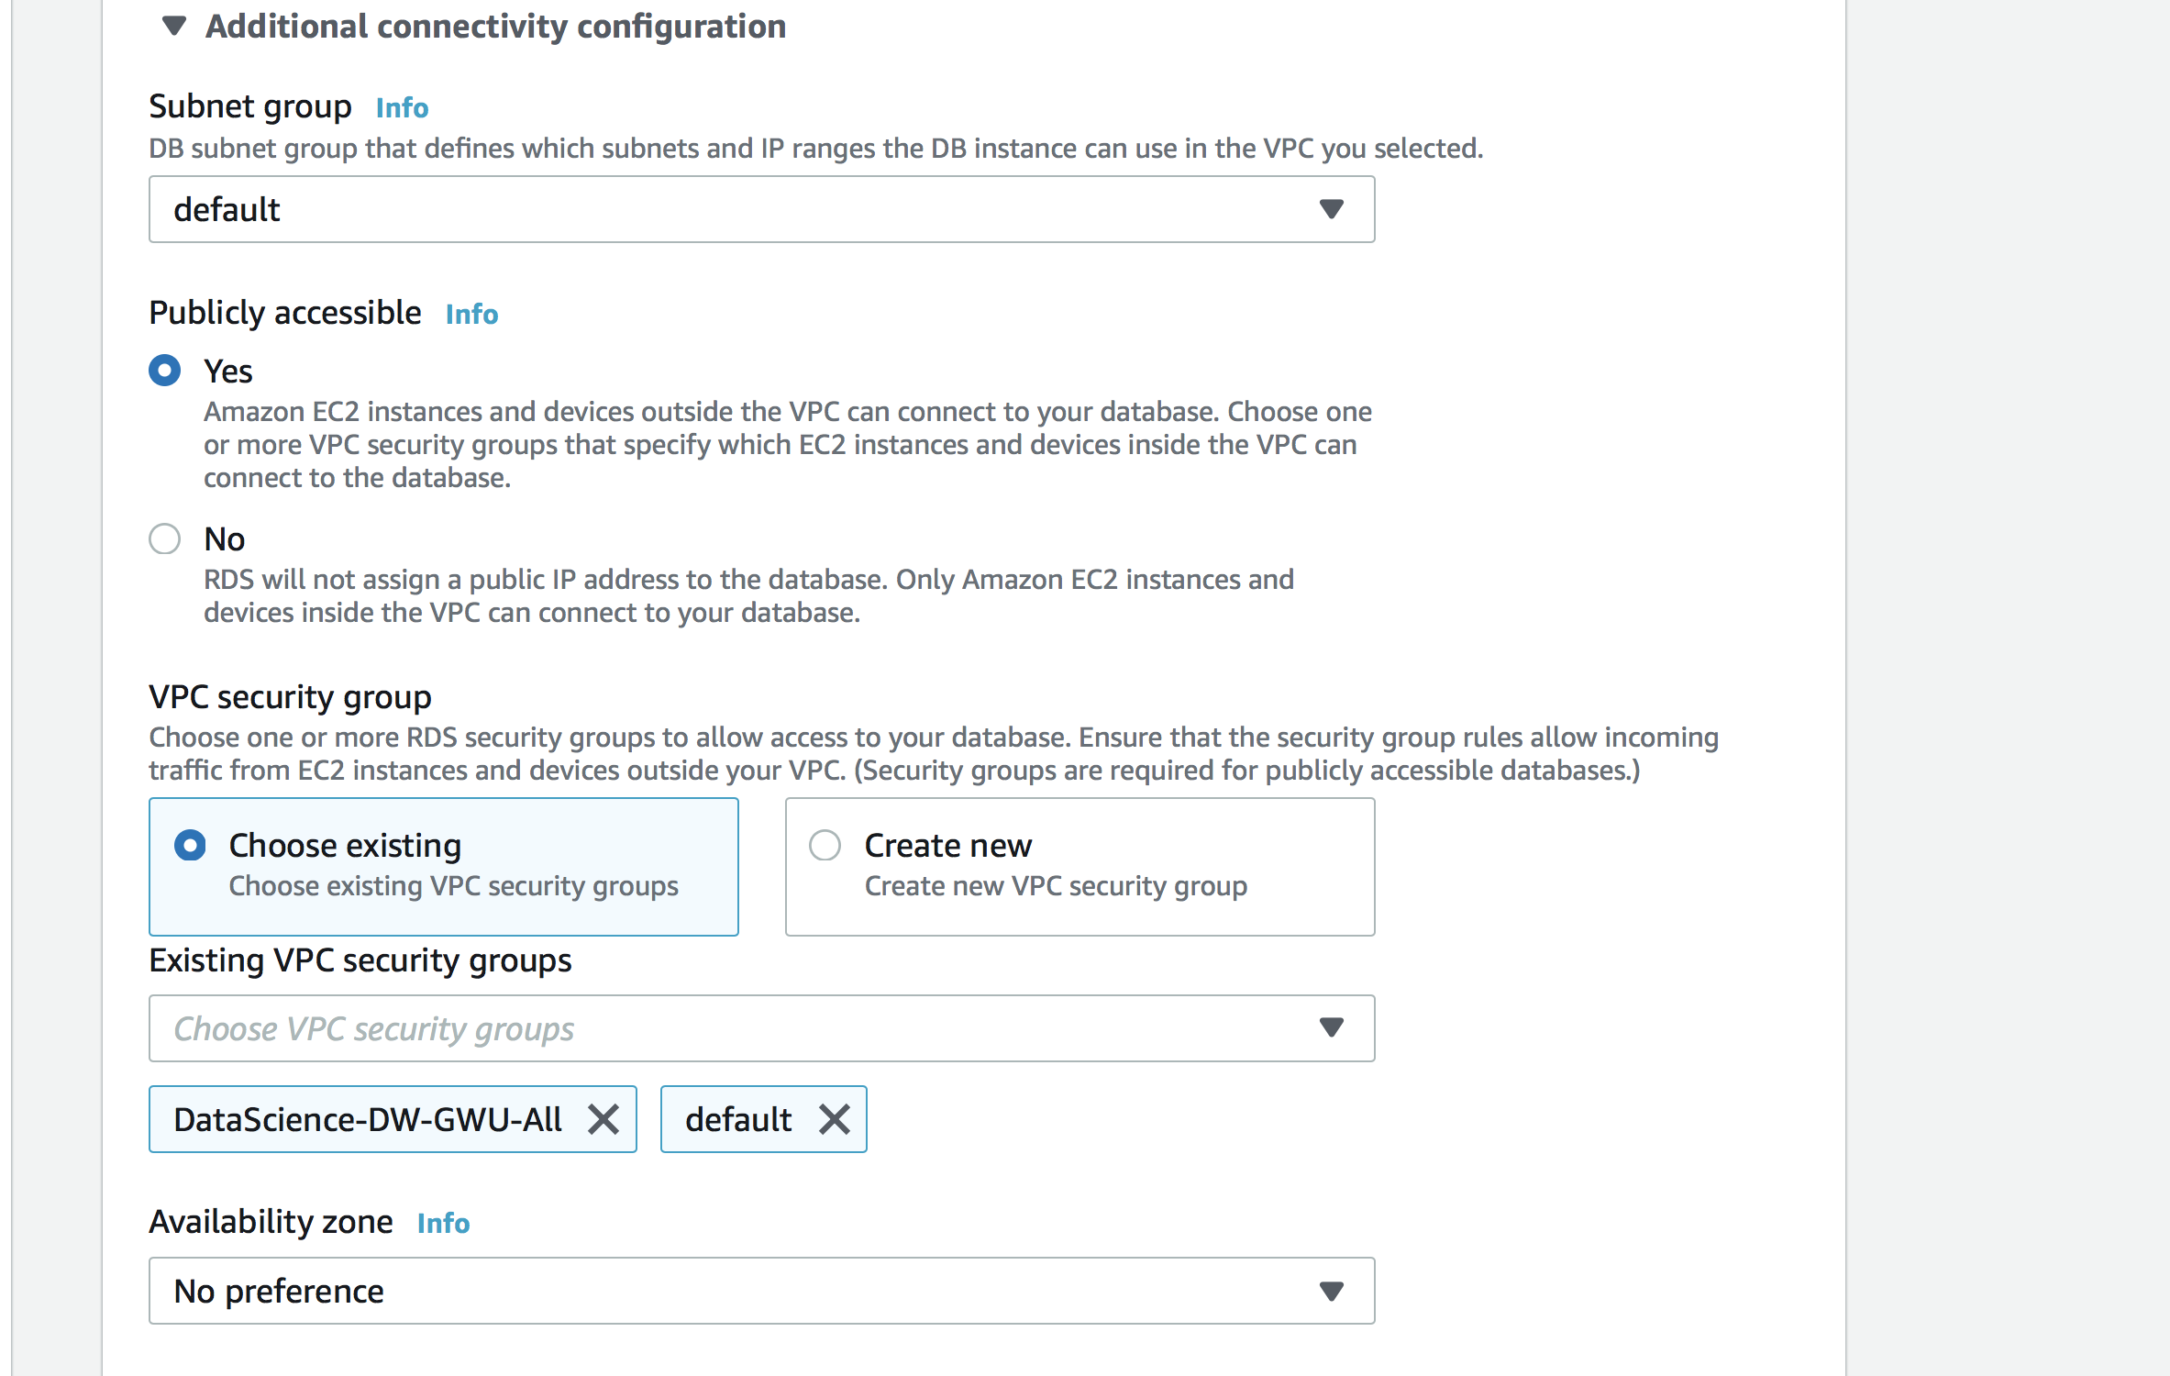

Leave all the other settings at default and click Create Database, it will take few minutes to launch, refresh to check

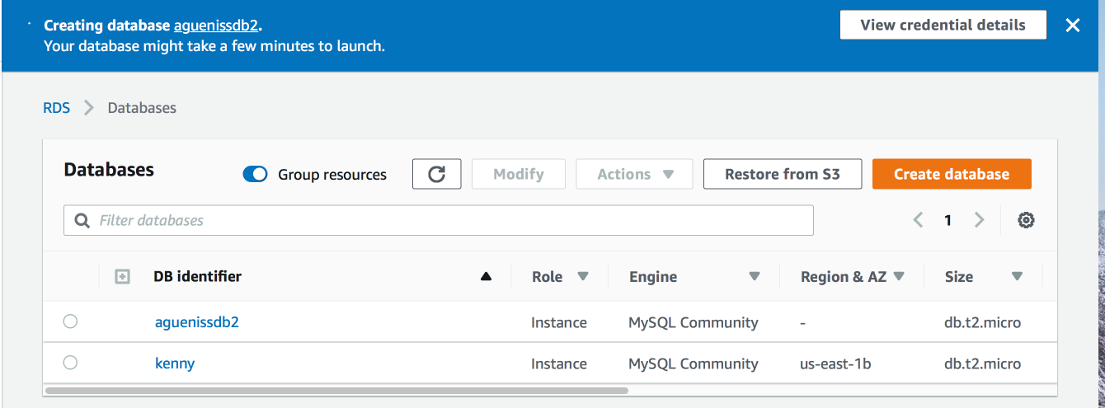

**Part IV**

Connect to MySQL RDS Database Instance with MySQL Workbench

1. Open MySQL Workbench, click **+** to create a connection

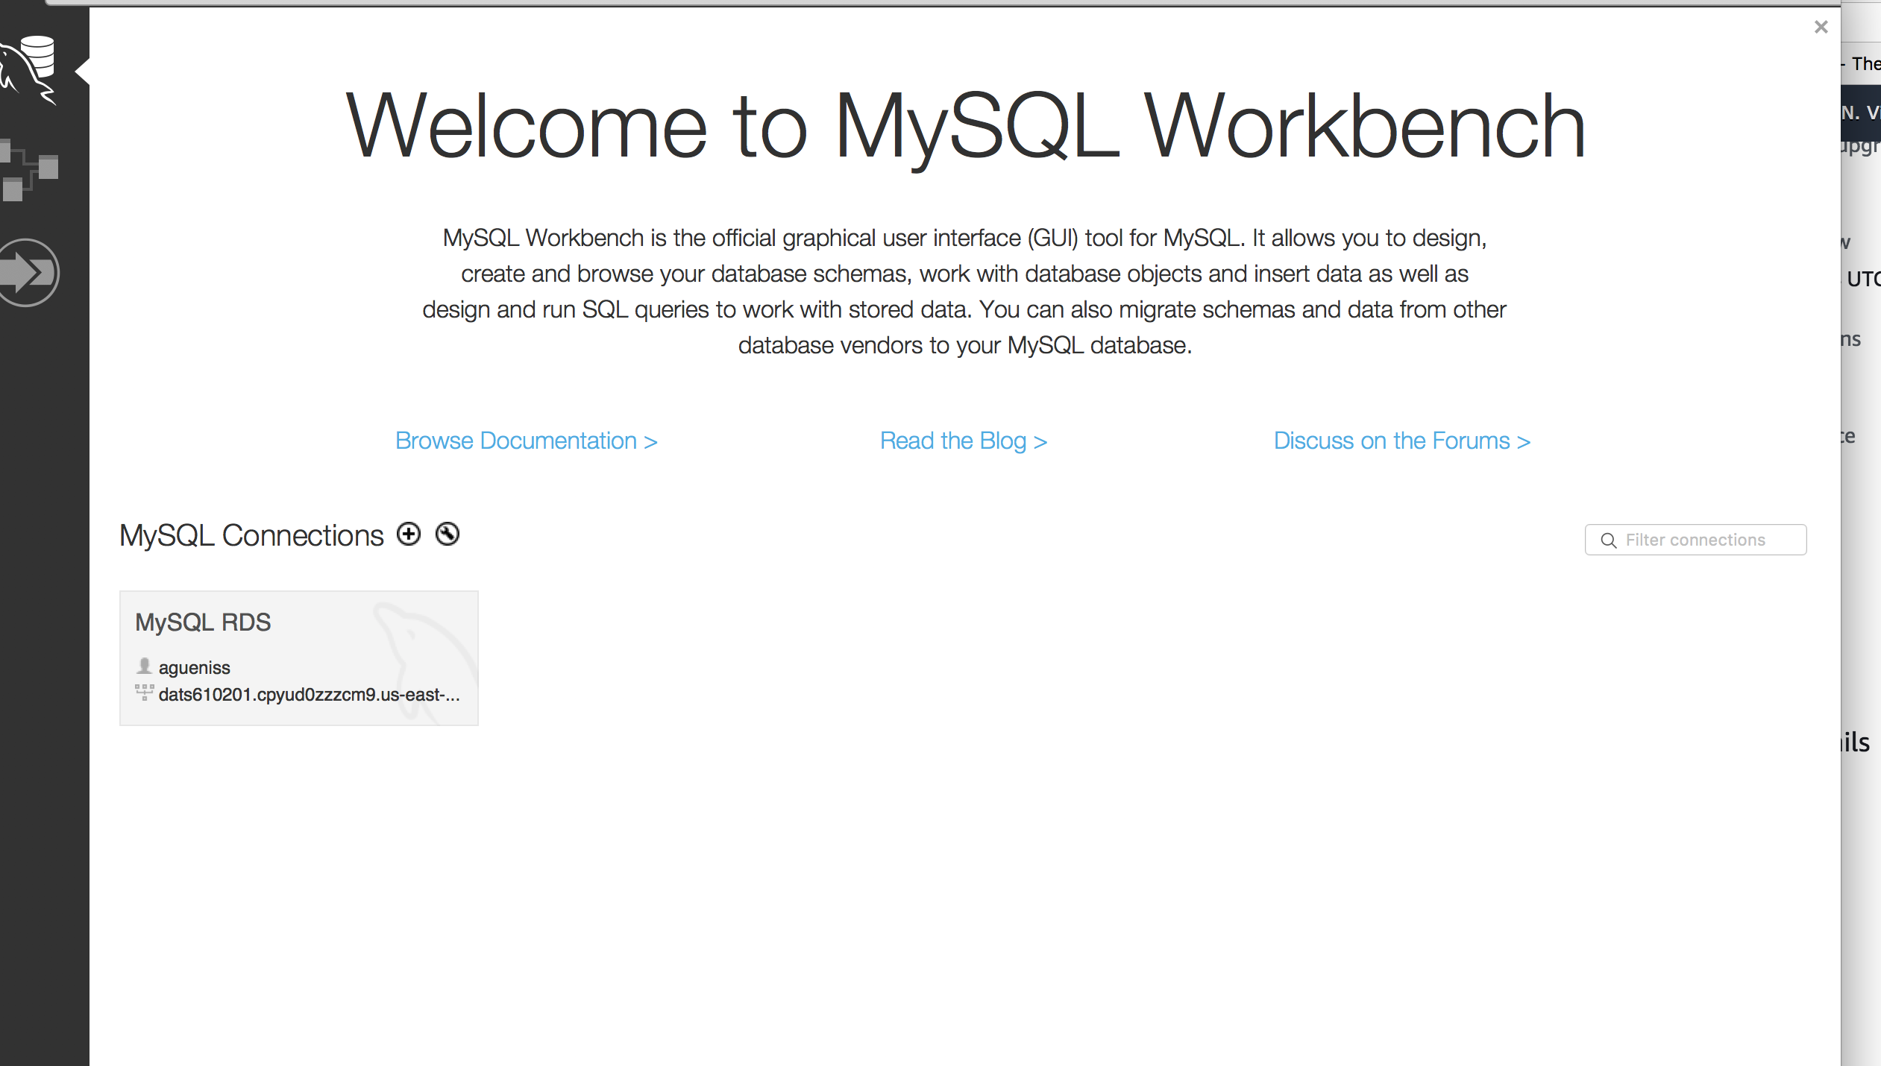

1. Go back to your RDS that you just created and navigate to **Connectivity & security** section and note Endpoint (that is the address of your database, below is the address of mine, yours will have its own address):

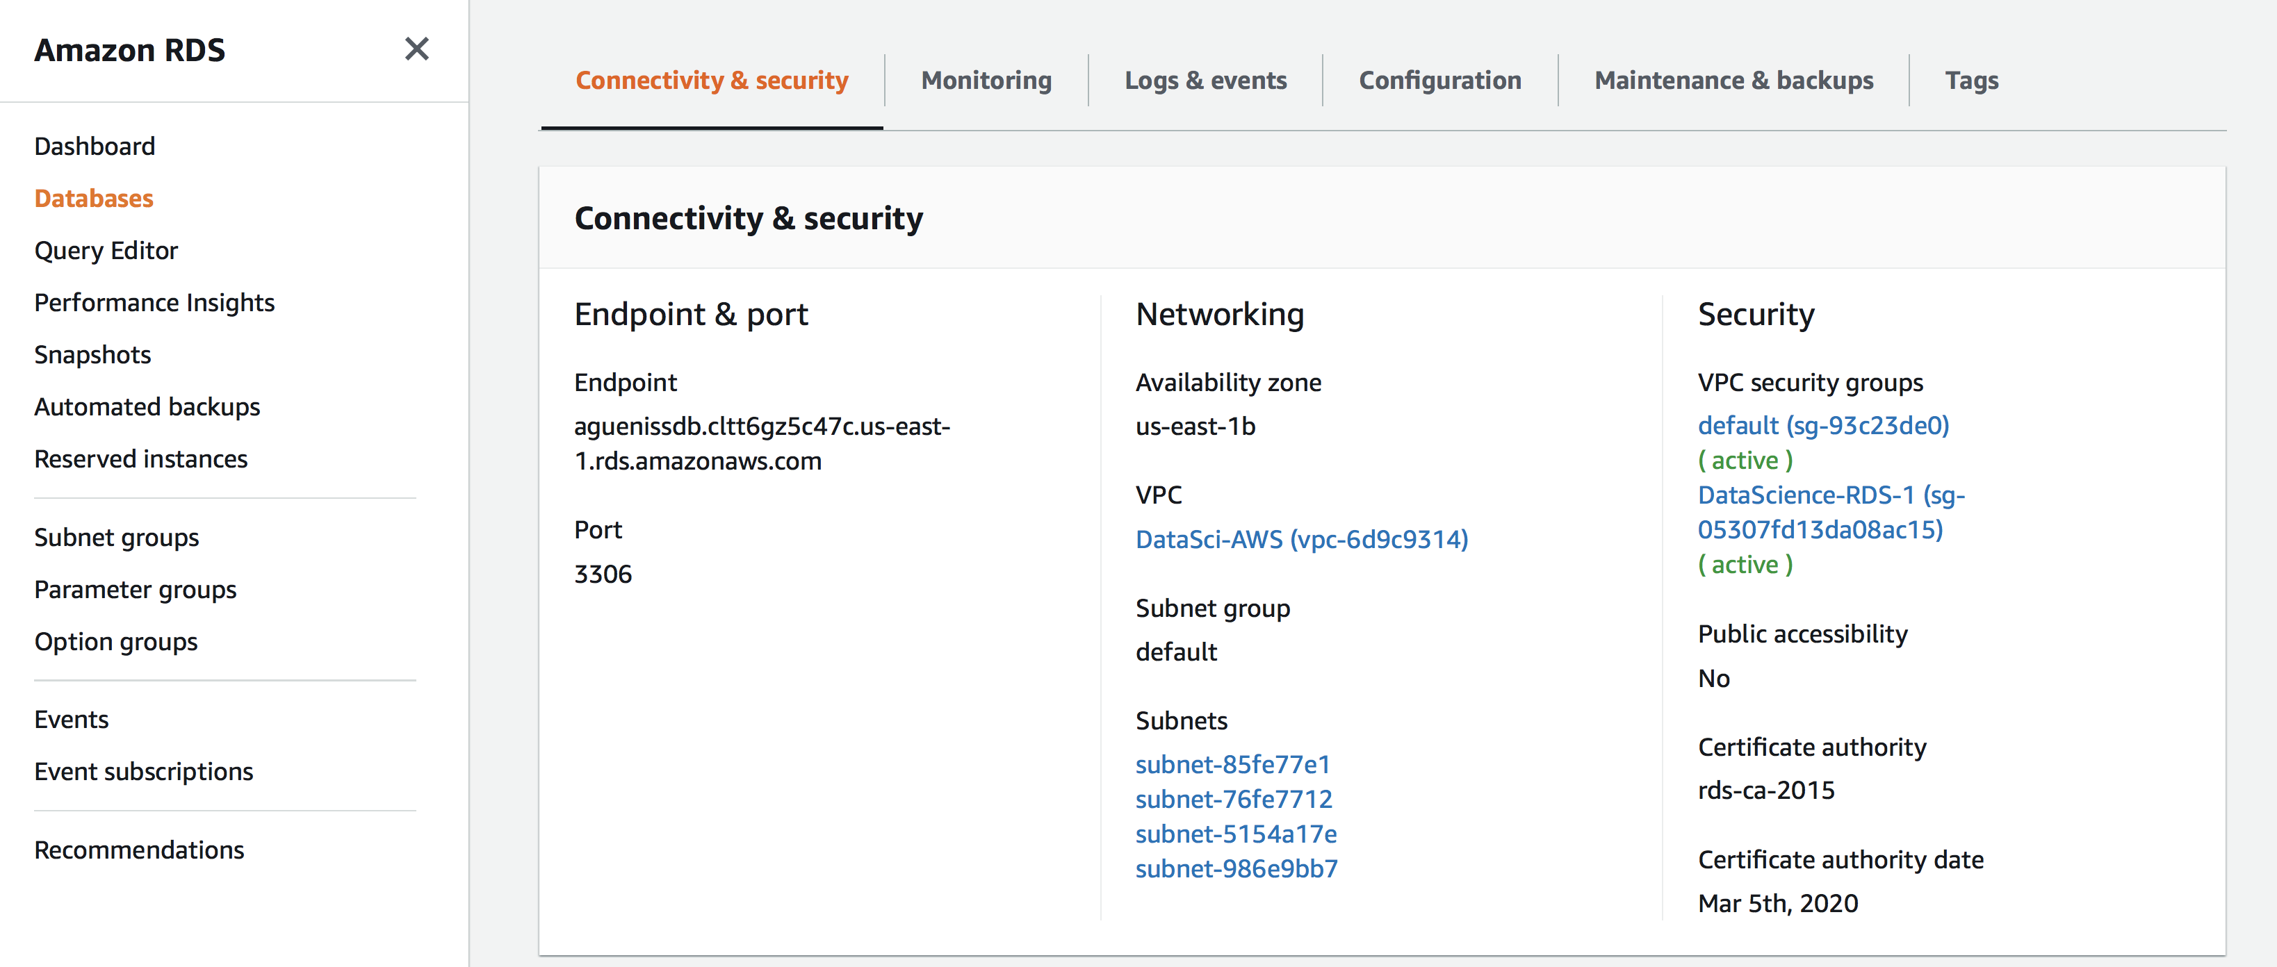

1. Set the following in MySQL Workbench:
2. **Connection name** (this is just an alias, you can make it whatever you want, but make it meaningful to you)
3. **Hostname** – set to **dats6102tuesday.c4mnrzxtzgcb.us-east-2.rds.amazonaws.com**
4. **Username – class_01**

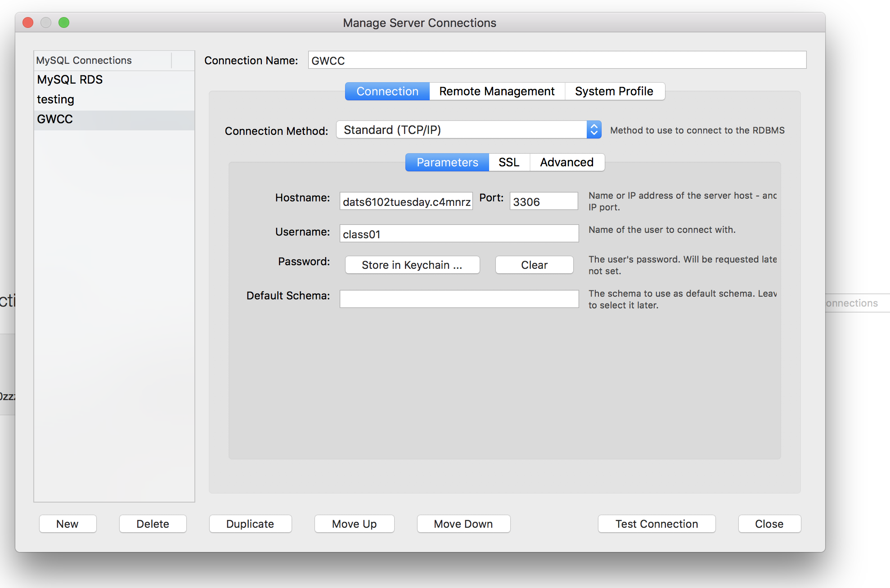

1. Click **Test Connection** and provide username/password that you saved for your Master user/password

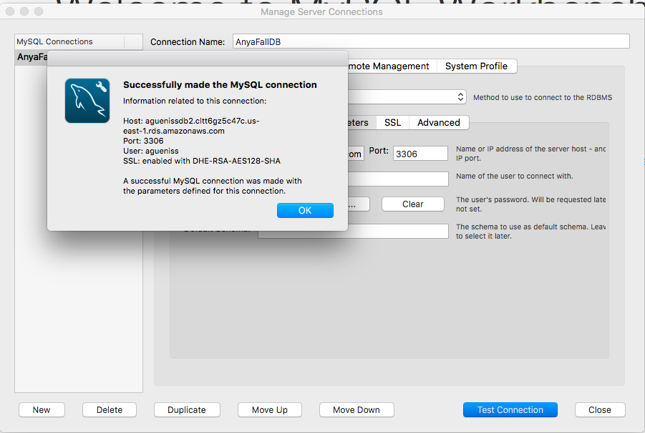

1. Click OK and you will be redirected to the **Welcome to MySQL Workbench screen**

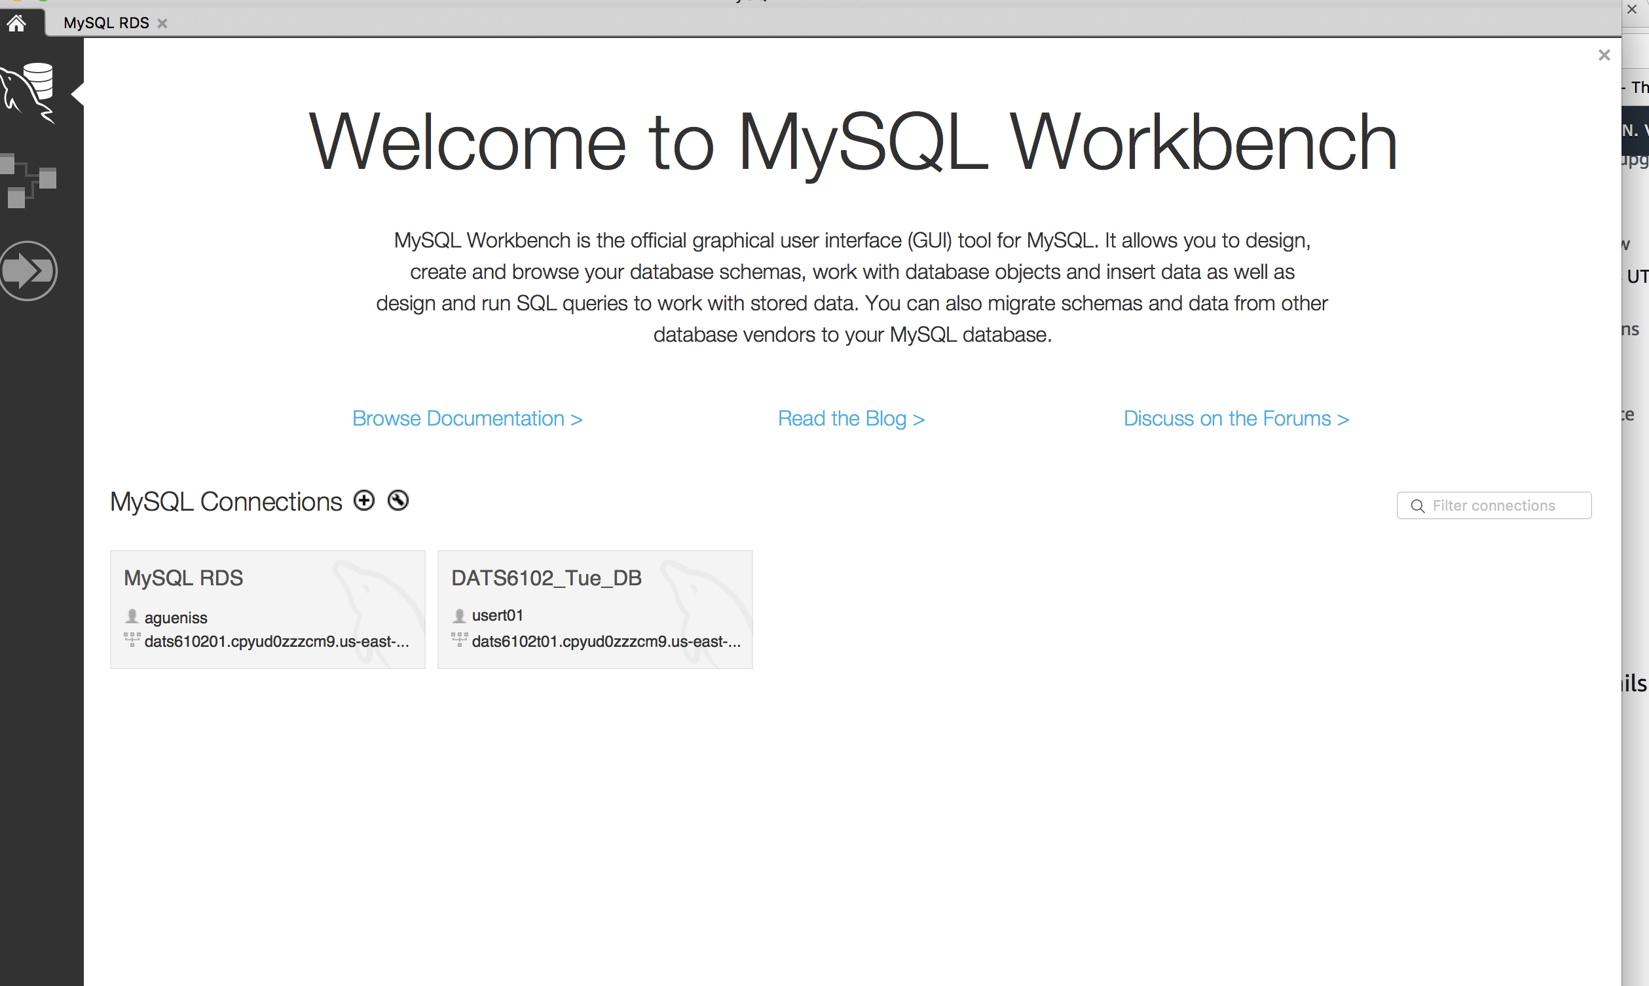

1. Click on the Connection you just created:

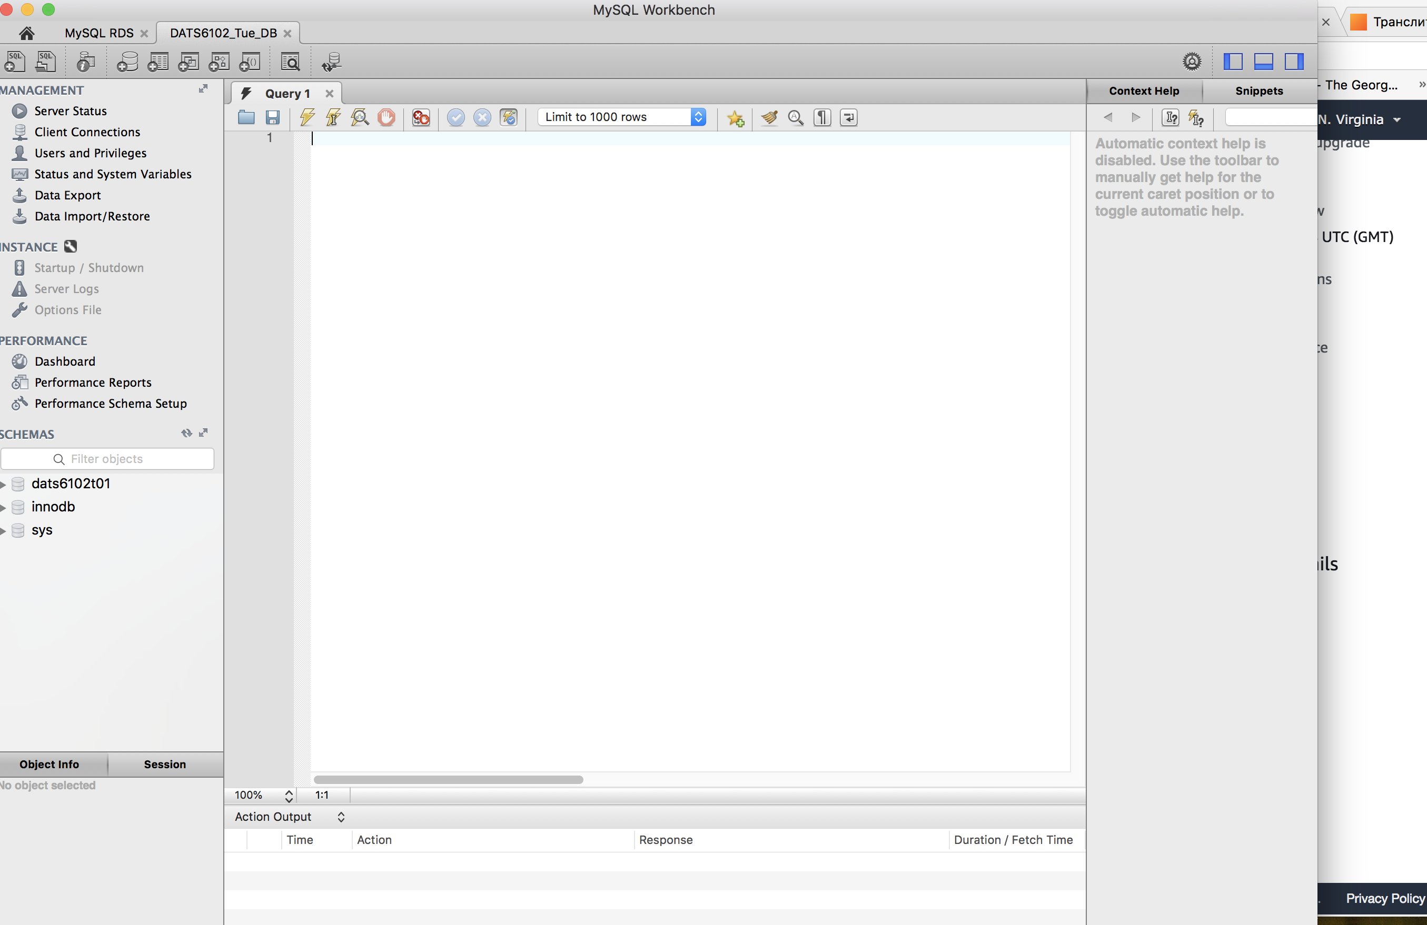

You have now accessed MySQL RDS from your client via MySQL Workbench!

**Part V**

Explore your RDS

* There is a lot you can do in MySQL Workbench
* Explore **SYS** Schema on the left 🡪 **sys_config** table

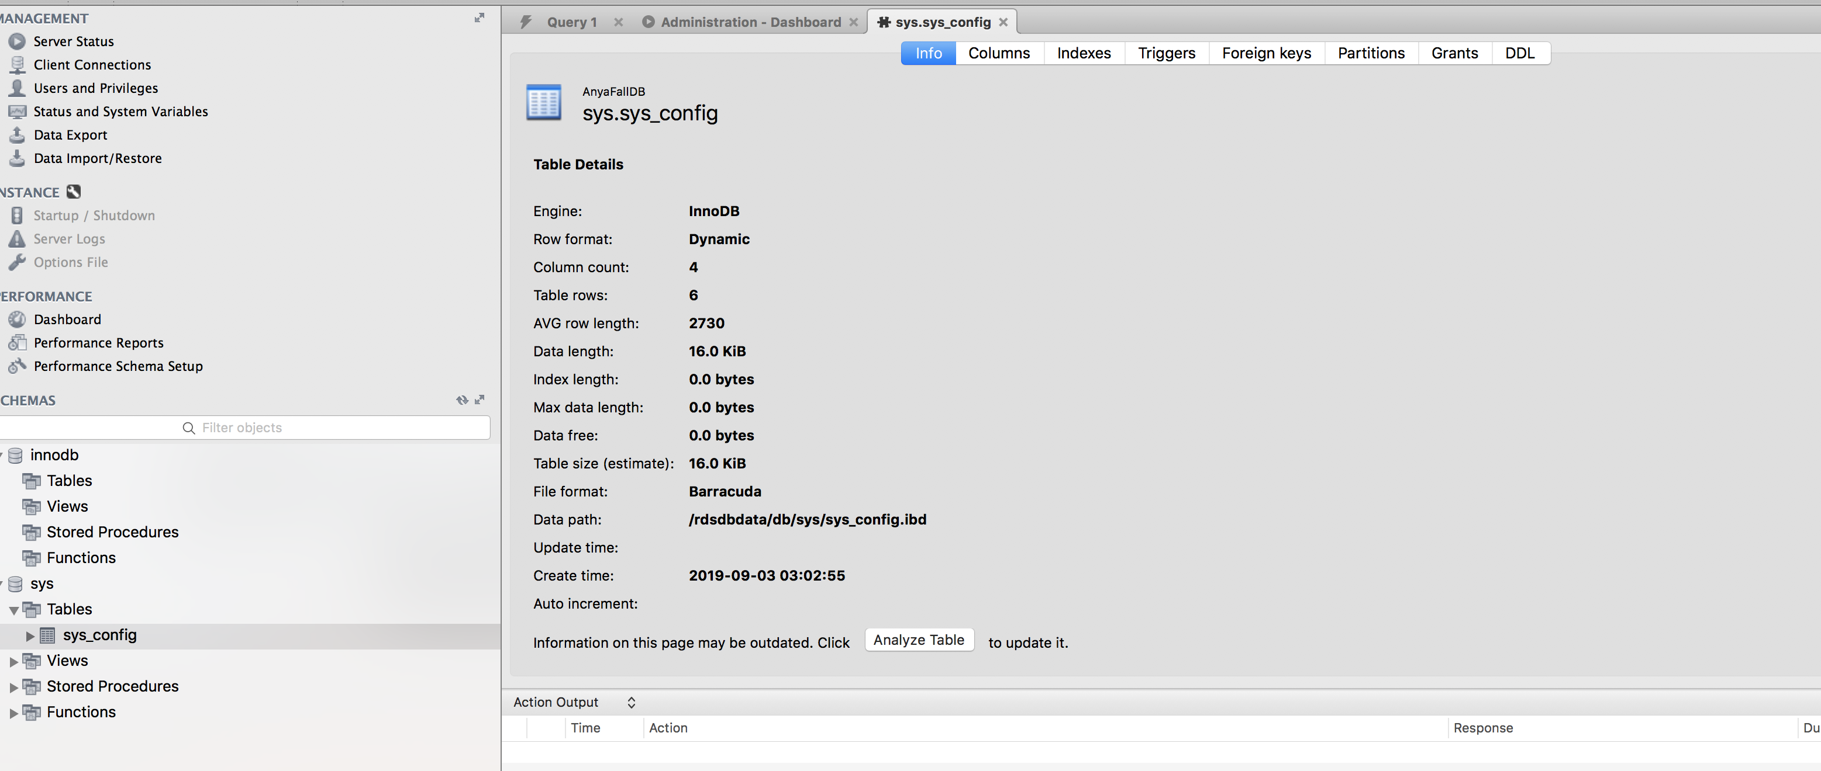

Copy below statements into Query1 tab and execute them one by one:

**USE sys**

**SELECT * FROM sys_config**

